**Q )Design a Program for creating machine that accepts the string always ending with 101.**

**CODE : -**

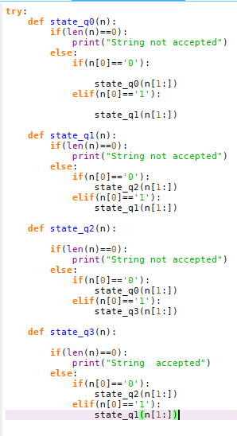

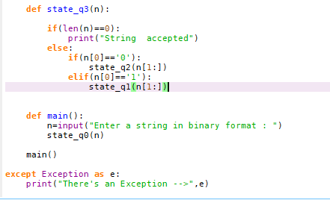

**OUTPUT : -**

